Client:
Product:
Title:
Length:
Writer:
Medium: Radio

MUSIC: THEME--UP. Establish. CONTINUE UNDER after 3 seconds. VOLUME SHOULD NOT INTERFERE WITH NARRATION.
ANNCR: Yes, friends! It’s time for Blah blah blah... Today's story from commercial land USA.
SOUND: SOUND EFFECT DESCRIPTION GOES HERE. YOU CAN CALL IT SOUND OR SFX, BUT WHATEVER YOU CALL IT, IT SHOULD BE UNDERLINED.
ANNCR: Blah Blah Blah with underline used for emphasis... and more blah. Some more blah, blah, blah and so on until something interrupts.
GIRL1: Blah Blah Blah with underline used for emphasis... and more blah blah.
Note: If you use a different length of character name, such as WOMAN 2 or EXPLORER, you will have to manually change the indenting of the second and subsequent lines of text so that they line up with the first line of text.
Delete this note when done creating your script.
NOTE: Remember: All words that are spoken are upper and lower case and double spaced.
Everything else is ALL CAPS and SINGLE SPACED.

Delete the following text and picture when done reading and using this tip. The picture below is an example of how you apply style. When you click on the style it makes the paragraph of text your cursor is on look like that style.

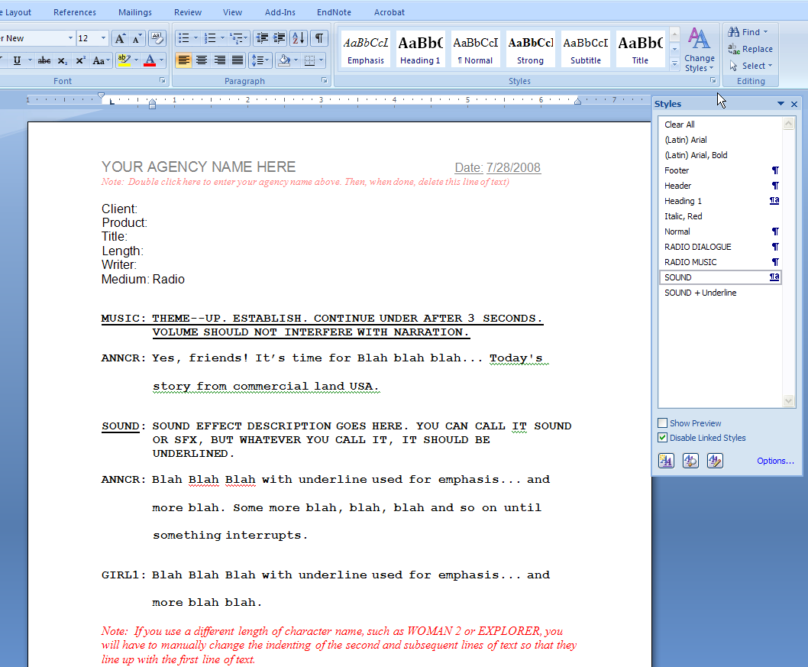
Special note. When you underline the word sound it creates a style that says SOUND + Underline. Do not use that as a style in the future because it will underline all the words. Use SOUND and always manually add the underline to the word SOUND or SFX
Click here to reveal styles

