Distinguish between convergent and parallel evolution. Which applies to neotropical and Old World monkeys?

Both convergent and parallel evolution refer to the similarities that exist between different organisms. Similarities that are the result of independent adaptations to similar habitats in animals that are very remotely related are examples of convergent evolution. Parallel evolution is similar to convergent evolution but occurs in organisms that are somewhat more closely related.
Similarities in neotropical and Old World monkeys are an example of parallel evolution; their occurrences are believed to have been channeled not only by similar selective pressures, but also by characteristics that were retained from the common ancestor. (Sansone 30)

Two remarkable prosimians exhibit representative cases of convergent evolution that are useful for understanding the term. The tarsier is a small, nocturnal mammal with disproportionately large eyes that feeds on insects and other like-sized animals. In part to make up for the lack of movement in its eye sockets, its head can swivel around backwards to open up its range of vision. Its ecological niche converges strikingly with owls elsewhere.

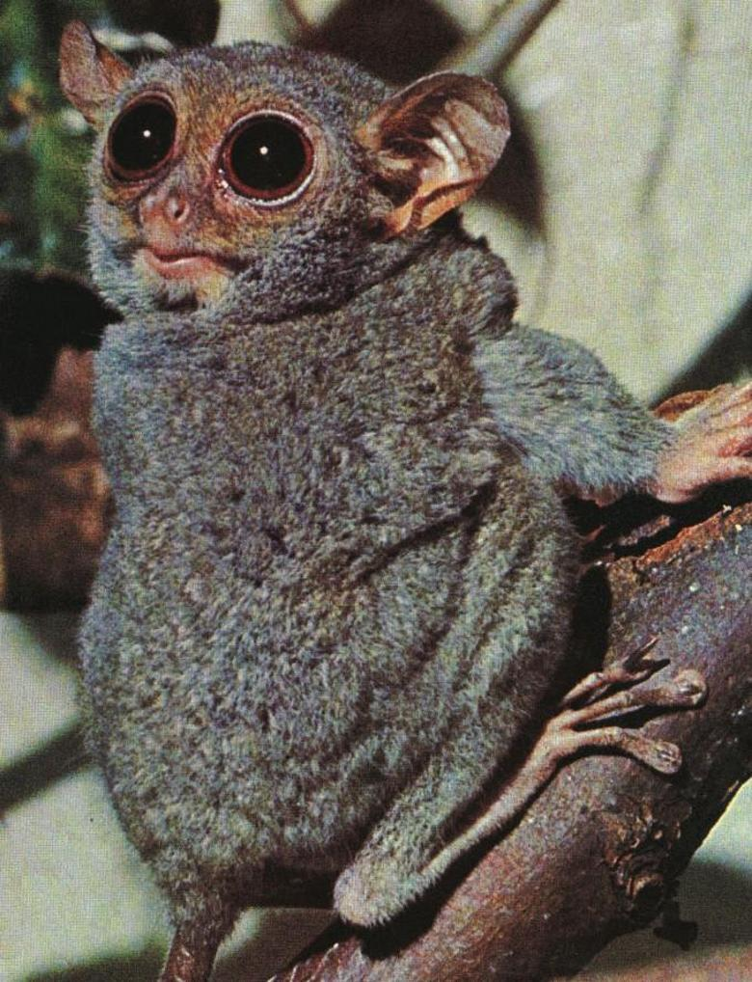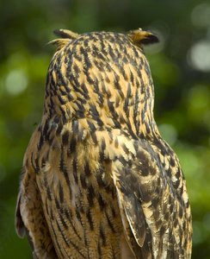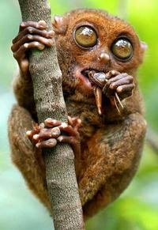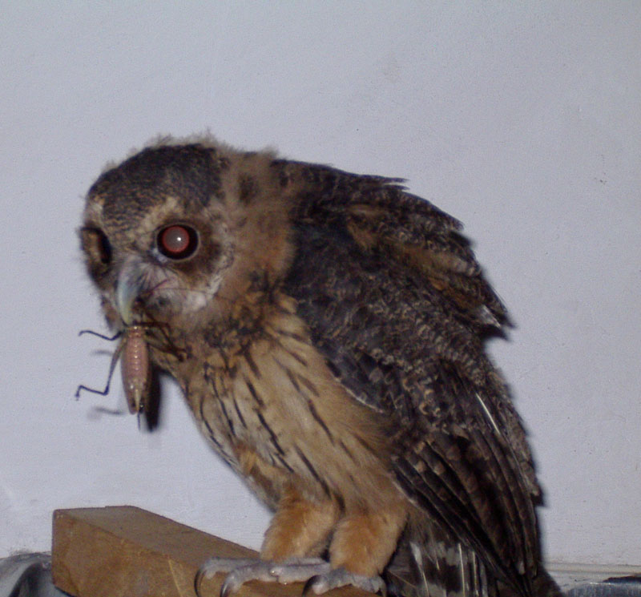

The aye-aye of Madagascar does not share as many morphological similarities with its avian ‘cousin’, but still serves as another impressive case of convergent evolution between two relatively unrelated species. In this situation, the aye-aye has a highly specialized finger that is used to tap on wood and to dig out grubs and other insects much like woodpeckers do with their beaks and barbed tongues. This is truly fantastic!

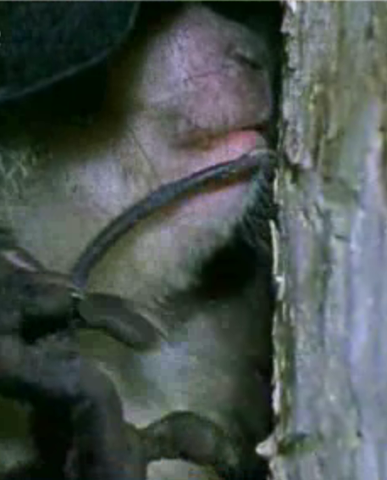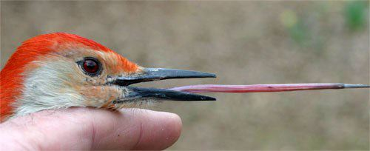
Exercise

Using the information from the article on convergent evolution, determine which ones of the following writing samples constitute plagiarism, and write why you feel that they are or are not.

As you review the samples with your instructor, insert descriptions showing you understand why each is or is not an example of plagiarism in the follow-up space provided, and correct your answers, even if all that needs correcting are slight changes in your explanation.

1.) It would be an oversight to believe there was only one sort of evolution. Punctuated evolution helps explain why there seem to be “missing links”; relative to geological time, the changes happen overnight! Convergent evolution is when two relatively unrelated species move into a similar niche. Parallel evolution is similar to convergent evolution, but it occurs in organisms that are somewhat more closely related. Similarities in neotropical and Old World monkeys are examples of parallel evolution.

Plagiarism: ____ Not plagiarism: ____

Explanation:
Follow-up:

2.) Tarsiers are interesting animals. They are very small, and have the cutest little hands. If it weren’t for their cute little noses, you’d think they were monkeys. Their head can swivel around backwards to look for things sneaking up behind them. Perhaps most remarkable are their disproportionately large eyes which allow them to see clearly in the dark (Bailey 1).

Plagiarism: ___ Not plagiarism: ____

Explanation:
Follow-up:

3.) Madagascar’s aye-ayes do not have as many mutual morphological resemblances with its feathered relative, but still provides a remarkable instance of convergent evolution involving two comparatively dissimilar species. In this circumstance, the aye-aye possesses an exceedingly specific finger that is utilized to beat on trees and hollow out grubs and additional creatures a good deal similar to what woodpeckers perform with their bills and hooked tongues.

Plagiarism: ____ Not plagiarism: ____

Explanation:
Follow-up:

4.) The mechanisms of evolution take on many different shapes. When two closely related species display similar characteristics, like those shared by Old and New World monkeys, it is called parallel evolution (Sansone 30). When the evolution occurs in two very different species that come to occupy unexpectedly similar ecological niches, like in the tarsier and owl or aye-aye and woodpecker, it is called convergent evolution (Bailey 1). Another example of convergent evolution would be the bill of the platypus and the mallard duck.

Plagiarism: ____ Not plagiarism: yes____

Explanation:
Follow-up:

5.) Elbow is in a particularly fortuitous position, as his schooling predates the clear emergence of composition as a separate “culture” and field within English departments, allowing his professional life to closely parallel the field’s materialization. This is truly fantastic! He was originally trained as a literature scholar and takes some time lamenting the shift in his academic energies. As he remarks, his first book was on Chaucer’s use of irony.

Plagiarism: ____ Not plagiarism: ____

Explanation:
Follow-up:

Image Credits

Woodpecker

tongue:
http://www.hiltonpond.org/images/WoodpeckerTongue02.jpg

Tarsier

eating cricket:
http://www.smh.com.au/ffximage/2005/03/11/s2_narrowweb__200x291.jpg

head backwards:
http://www.eyedesignbook.com/ch3/eyech3-h.html
http://www.eyedesignbook.com/ch3/fig3-54tarsierBG.jpg (image URL)

Owl

Owl with cricket:
http://www.owlpages.info/gallery/displayimage.php?album=topn&cat=0&pos=7
http://www.owlpages.info/gallery/albums/userpics/10090/Claudia 02 no-red eye.jpg

White barn owl with head backwards:
http://www.suite101.com/files/topics/19390/files/BarnOwlWeb.jpg

Aye-aye

Movie (from which aye-aye finger picture was taken):
http://www.arkive.org/species/GES/mammals/Daubentonia_madagascariensis/Daubentonia_madagascar_08d.html?=&movietype=Download+QuickTime+movie&host=192.168.1.1

Copyright Info: This web site is © Wildscreen Trading Limited (1998). Material contained in this site is © Wildscreen Trading Limited or its contributors.

